


Headteacher: Mr Gavin Beetham
Desford Road
Thurlaston
Leicester
7th October 2022 LE9 7TE
Telephone: 01455 888243
email: office@thurlaston.leics.sch.uk
website: www.thurlaston.leics.sch.uk
Dear Parent/Carer,

I trust that those who were able to join us for our Harvest Service in Church last Friday enjoyed it. The donations have already been taken to the Fosse Villages Foodbank. Thank you.

Unfortunately there was a miscommunication with the organisation of the Football Tournament on Friday. A new date has been scheduled on 28th October. A replacement letter has been sent to Class 4 children who are interested in taking part. Please return by Monday at the latest.

Four of our children from Class 4 went to the Sports Ambassador training at Countesthorpe Academy this week. They have already made a presentation and run an assembly encouraging children to be more active. Well done.

Thank you to all the parents who kept to time on parents evening. It is very much appreciated. I trust you all found the evening helpful.

Next Wednesday (12th) reception parents are invited to see phonics teaching in action. This will be from the start of the day to around 11:15am. Please note that this is for parents only as we will not have space to accommodate others (such as younger siblings).

We will be holding an Open Day for prospective parents on 28th October from 9:30am to 3pm. There is no need for parents to book a slot they can just turn up and see the school as it is on a normal day. Please encourage parents of children who are due to start school next autumn to come and have a look around. We also have some space in some year groups.

Please can all photograph orders be returned by Monday.

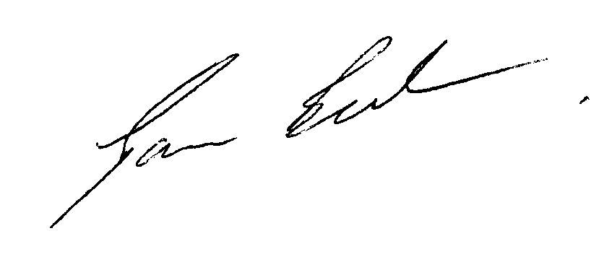
Yours sincerely

Gavin Beetham

Provisional Dates for your Diary
29th November – KS2 Pantomime
6th and 7th December – KS1 Nativity
13th December –KS1 Party
16th December – Carol Service in Church at 2pm.

…………………………………………………………………………………………………………………………………………..
Term dates 2022/2023

Autumn Term
Schools open: | Tuesday 30 August 2022
Half term break: | Monday 17 to Friday 21 October 2022
Schools close: | Friday 16 December 2022

Spring Term
Schools open: | Tuesday 3 January 2023
Half term break: | Monday 20 to Friday 24 February 2023
Schools close: | Friday 31 March 2023

Summer Term
Schools open: | Monday 17 April 2023
May Day Bank Holiday: | Monday 1 May 2023
Half term break: | Monday 29 May to Friday 2 June 2023
Schools close: | Wednesday 12 July 2023
Please note school opens on 30th August 2022 for the start of the academic year following clarification from the LA.

