Division
Refer to NCETM Singapore bar article
Refer to NCETM Progression in Reasoning document
Year 4 | Year 5 | Year 6
Mental Strategies  Children should experience regular counting on and back from different numbers in multiples of 6, 7, 9, 25 and 1000.  Children should learn the multiplication facts to 12 x 12.  Vocabulary  see years 1-3  divide, divided by, divisible by, divided into  share between, groups of  factor, factor pair, multiple  times as (big, long, wide …etc)  equals, remainder, quotient, divisor  inverse  Towards a formal written method  Alongside pictorial representations and the use of models and images, children should progress onto short division using a bus stop method.  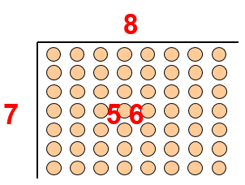  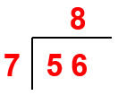  Place value counters can be used to support children apply their knowledge of grouping. Reference should be made to the value of each digit in the dividend.  Each digit as a multiple of the divisor  ‘How many groups of 3 are there in the hundreds column?’  ‘How many groups of 3 are there in the tens column?’  ‘How many groups of 3 are there in the units/ones column?’  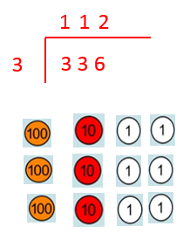  When children have conceptual understanding and fluency using the bus stop method without remainders, they can then progress onto ‘carrying’ their remainder across to the next digit.  Generalisations  True or false? Dividing by 10 is the same as dividing by 2 and then dividing by 5. Can you find any more rules like this?  Is it sometimes, always or never true that □ ÷ ∆ = ∆ ÷ □?  Inverses and deriving facts. ‘Know one, get lots free!’ e.g.: 2 x 3 = 6, so 3 x 2 = 6, 6 ÷ 2 = 3, 60 ÷ 20 = 3, 600 ÷ 3 = 200 etc.  Sometimes, always, never true questions about multiples and divisibility. (When looking at the examples on this page, remember that they may not be ‘always true’!) E.g.:  - Multiples of 5 end in 0 or 5.  - The digital root of a multiple of 3 will be 3, 6 or 9.  - The sum of 4 even numbers is divisible by 4. | Mental Strategies  Children should count regularly using a range of multiples, and powers of 10, 100 and 1000, building fluency.  Children should practice and apply the multiplication facts to 12 x 12.  Vocabulary  see year 4  common factors  prime number, prime factors  composite numbers  short division  square number  cube number  inverse  power of  Generalisations  The = sign means equality. Take it in turn to change one side of this equation, using multiplication and division, e.g.  Start: 24 = 24  Player 1: 4 x 6 = 24  Player 2: 4 x 6 = 12 x 2  Player 1: 48 ÷ 2 = 12 x 2  Sometimes, always, never true questions about multiples and divisibility. E.g.:  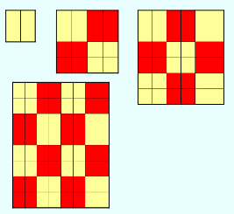  - If the last two digits of a number are divisible by 4, the number will be divisible by 4.  - If the digital root of a number is 9, the number will be divisible by 9.  - When you square an even number the result will be divisible by 4 (one example of ‘proof’ shown left) | Mental Strategies  Children should count regularly, building on previous work in previous years.  Children should practice and apply the multiplication facts to 12 x 12.  Vocabulary  see years 4 and 5  Generalisations  Order of operations: brackets first, then multiplication and division (left to right) before addition and subtraction (left to right). Children could learn an acrostic such as PEMDAS, or could be encouraged to design their own ways of remembering.  Sometimes, always, never true questions about multiples and divisibility. E.g.: If a number is divisible by 3 and 4, it will also be divisible by 12. (also see year 4 and 5, and the hyperlink from the Y5 column)  Using what you know about rules of divisibility, do you think 7919 is a prime number? Explain your answer.  Some Key Questions for Year 4 to 6  What do you notice?  What’s the same? What’s different?  Can you convince me?  How do you know?

